

Library System

**Done by:**

**Abdullah Aktham Khaleel – 202004678**

**Maha Mohammed Ali – 202002565**

**Fatema Salman Abbas – 202005779**

**Musherah Moqbel Ali – 202002276**

**Submitted On:**

**May 29th, 2022**

**Submitted To:**

**Dr. Mustafa Mohammad Hammad**



**Table of Contents**

1. Introduction 4

1.1 Purpose 4

1.2 Scope: 4

1.3 Product Perspective 4

1.4 Product Requirements 5

1.4.1 Functional Requirements: 5

1.4.2 Non-functional Requirements 7

1.5 User Characteristics: 9

1.6 Principal Stakeholders: 9

1.7 General Constraints: 9

2. System’s Components 10

2.1 Component description 10

2.1.1 User identification 10

2.1.2 User activity 10

2.1.3 Feedback activity 10

2.1.4 Technical issue 10

2.2 The role of stockholders 12

2.3 Functional requirement: 12

2.4 Use cases related to User identification: 12

2.5 Use cases related to User activity: 15

2.6 Use cases related to Feedback activity: 18

2.7 Use cases related to technical issue: 19

2.8 UML Use Cases Diagrams 21

2.8.1 user identification 21

2.8.2 related to User activity: 22

2.8.3 related to feedback activity 23

2.8.4 related to technical issue: 24

2.9 Performance Requirements: 25

2.10 Design Constraints: 25

2.11 External Interface Requirements: 25

2.12 Future Extensions: 25

3. UML Class Diagram 26

3.1 User Identification 26

3.2 user Activity 27

3.4 Feedback Activity 28

3.5 Technical issue 29

4. Dynamic model 30

4.1 Sequesnail diagram 30

4.1.1 Feedback Activity 30

4.1.2 User Activity 31

4.1.3 User Identification 32

4.1.4 Technical issue 33

4.2 state diagram 35

4.2.1 Feedback Activity 35

4.2.2 User Activity 36

4.2.3 User Identification 37

4.1.4 Technical issue 38

4.3 Activity Diagram 39

4.3.1 Feedback Activity 39

4.3.2 User Activity 40

4.3.3 User Identification 41

4.3.4 Technical issue 42

5. Database Relational Schema 43

5.1 Feedback Activity 43

5.2 User Activity 44

5.3 User Identification 45

5.4 Technical issue 46

6. GUI Prototype 47

6.1 Feedback Activity 47

6.2 User Activity 50

6.3 User Identification 58

6.4 Technical issue 62

Conclusion 64

# Introduction

1.1 Purpose

This system will help students and academic staff to access the books they need or resources that can benefit them in their specialization. A large and diverse library of these books will be provided to them, and the books will be divided according to the type of specialization to help students expand their field by providing books related to the field and taking A simple overview of other disciplines and also the provision of some books that help students in life after university.

1.2 Scope:

We describe what features are in the scope of the software and what are not in the scope of the software to be developed.

*In Scope:*

1. Allow multiple payment methods
2. Facilitate the process of book searching and reserving.
3. Suggesting related books for more information.
4. allow students to display their used books for sale.
5. User authentication.
6. View book prices with a simple overview of each book

*Out of Scope:*

1. Delivery of sold or borrowed books, outside the library management system.
2. quality of books offered for sale by students.
3. Our platform is considered non-profitable from displaying or selling books.

**1.3 Product Perspective**:

ULMS is intended to help students and other academic members and access to open-source books and articles that can be used to help them in understanding their subjects in-depth and search for other opinions in one field, and the System will help them to search, reserve, and sell their books or articles, System must be easy to understand and interact; also our System considers a dependency-software because it depends into other systems such as a database of the books, students, and academics members. It considers a cross-platform system to allow students to access the program from different devices.

* 1. **Product Requirements**:

1.4.1 Functional Requirements:

|  |  |
| --- | --- |
| Requirement ID | GDC-BDW-WE2 |
| Title | Verification |
| Priority | medium level (optional requirement) |
| Description | The system sends a confirmation message to the student’s university email when logging in to the application. (Test by internship students) |
| Version | 1.0 |

|  |  |
| --- | --- |
| Requirement ID | UND-X4C-I |
| Title | Authentication |
| Priority | High level (core requirement) |
| Description | The program authenticates the student: when the student logs in to the application, the application authenticates the student, and all his university data appears in the application. (Test by internship students) |
| Version | 1.0 |

|  |  |
| --- | --- |
| Requirement ID | BEW-BEL-CS2 |
| Title | Assist ability |
| Priority | High level (core requirement) |
| Description | The application is an assistant to the student in search operations: the application shows books related to the student's major to facilitate the search process. |
| Version | 1.0 |

|  |  |
| --- | --- |
| Requirement ID | JGK-DHW-29K |
| Title | Rating and communication ability |
| Priority | medium level (optional requirement) |
| Description | The application allows the student to evaluate books: the student can write a comment to express his opinion and evaluation of the book. When the user post comment, the comment must be appeared to other users. |
| Version | 1.0 |

|  |  |
| --- | --- |
| Requirement ID | DGE-GKD-HJD |
| Title | sale books |
| Priority | High level (core requirement) |
| Description | Helps students to display books for sale: The application allows students to display used books for sale, student should be able to sale 3 books per day. Check throw training |
| Version | 1.0 |

|  |  |
| --- | --- |
| Requirement ID | KGC-DKW-LBD |
| Title | Payment method |
| Priority | low level (fancy requirement) |
| Description | Multiple payment methods: the application provides and allows the student to pay in more than one way, by credit card, visa, cash and benefit. |
| Version | 1.0 |

|  |  |
| --- | --- |
| Requirement ID | KDI-CKE-DKF |
| Title | reporting |
| Priority | low level (fancy requirement) |
| Description | System must provide monthly reports regarding number of books and the new books that have been added and number of users. |
| Version | 1.0 |

|  |  |
| --- | --- |
| Requirement ID | DEF-CDW-FED |
| Title | Background application |
| Priority | low level (fancy requirement) |
| Description | The background of the system must be green in all section except the section of payment. |
| Version | 1.0 |

|  |  |
| --- | --- |
| Requirement ID | GXR-BDE-BRE |
| Title | Transaction corrections |
| Priority | medium level (optional requirement) |
| Description | The system must be able to do each transaction in the correct way or it will be rejected by the system, each transaction must have a permanent change into the system. |
| Version | 1.0 |

|  |  |
| --- | --- |
| Requirement ID | WQE-CME-VKE |
| Title | contact form |
| Priority | High level (core requirement) |
| Description | Contact form that enables users to send their feedback regarding the experience of the system. It can be tested in the training day. |
| Version | 1.0 |

1.4.2 Non-functional Requirements

|  |  |
| --- | --- |
| Requirement ID | CEP-CDE-FVE |
| Title | Performance |
| Priority | High level (core requirement) |
| Description | The speed of our system's response to the actions of the users under a certain workload will be less than 3 seconds. |
| Version | 1.0 |

|  |  |
| --- | --- |
| Requirement ID | FEQ-DNC-JEL |
| Title | Security |
| Priority | High level (core requirement) |
| Description | The system will have a high level of security and all data inside the system will be protected from malware attacks or unauthorized access. The system also must be block any comments contain a links. |
| Version | 1.0 |

|  |  |
| --- | --- |
| Requirement ID | QWR-GFE-BFE |
| Title | Portability |
| Priority | High level (core requirement) |
| Description | The system can work in all different platforms, and perform all required procedures and percentage of target-dependent statement should be less than 20% |
| Version | 1.0 |

|  |  |
| --- | --- |
| Requirement ID | DJC-DI4-BCE |
| Title | Reliability |
| Priority | medium level (core requirement) |
| Description | The system or one of its components can operate without failure for a period. Under normal conditions of use, the system must achieve a 98% of not suffering from a critical failure. |
| Version | 1.0 |

|  |  |
| --- | --- |
| Requirement ID | DEP-VDE-EOP |
| Title | Availability |
| Priority | High level (core requirement) |
| Description | system must be available 24/7/365, so the user will be able to access the system at any time. |
| Version | 1.0 |

|  |  |
| --- | --- |
| Requirement ID | DGB-CDK-DKK |
| Title | Usability |
| Priority | medium level (optional requirement) |
| Description | It will be easy for the user to use the system and interact with it and we will create help frames that appear some hints to help users interact with the system. |
| Version | 1.0 |

|  |  |
| --- | --- |
| Requirement ID | KDE-CDE-PEF |
| Title | Maintainability |
| Priority | High level (core requirement) |
| Description | The system will be supported, changed, enhanced, and restructured over time easily and the time of maintenance must not exceed 3 hours. |
| Version | 1.0 |

|  |  |
| --- | --- |
| Requirement ID | GDE-CEI-F4I |
| Title | Network intensiveness |
| Priority | medium level (optional requirement) |
| Description | The system will serve the needs of a diverse community of students and academic members. |
| Version | 1.0 |

|  |  |
| --- | --- |
| Requirement ID | CDJ-DKD-KDP |
| Title | Concurrency |
| Priority | medium level (optional requirement) |
| Description | A large number of users will be able to access the system at one time the number must be more than 200 user at the same moment. |
| Version | 1.0 |

|  |  |
| --- | --- |
| Requirement ID | CEE-KFE-WSW |
| Title | supportability |
| Priority | High level (core requirement) |
| Description | it will be easy to change the system when we want to add new feature or change anything in the system, changing the system form a platform to another take at most two weeks. |
| Version | 1.0 |

1.5 User Characteristics:

1. The user must be a university student or doctor.
2. The user must be familiar with the types of books and their classifications.
3. The user must have knowledge of the English language.

1.6 Principal Stakeholders:

Students, university members

1.7 General Constraints:

1. The student is allowed to borrow only 3 books at the same time, as a maximum.
2. Each student is allowed to display only 5 books for sale.
3. ULMS is a single user program.
4. Internet connection required.

# System’s Components

2.1 Component description

2.1.1 User identification

Every student or doctor in the university is allowed to create an account through his university email, then he can log in to the system at any time by email or username, on more than one device at the same time.

2.1.2 User activity

These activities help the student to access the books he needs in his academic career at the university, to facilitate his study and gain information in a larger quantity and in less time, where the student can buy, sell, borrow, reserve, delete and return books through the application quite easily through several simple, diverse and easy procedures.

2.1.3 Feedback activity

This activity will help the students to report or suggest new books for their library, also it is give the opportunity to student to rate any purchased book and help other student to know whether this books is good or not, also share the knowledge between students throw suggest activity.

2.1.4 Technical issue

This activity will focus on contact, cancel purchase, report problem. This part considers as technical part that help students to share their problems and our solutions. Also, it will help them if there is any book that they didn’t like it they can simply return it throw cancel purchase activity.

|  |  |  |
| --- | --- | --- |
| Component Name | Use Case Name | Description |
| User identification  (Maha Mohammed) | register | Every student or doctor in the university is allowed to create an account through his university email. |
| Login | The user can log in to his account at any time and on more than one device at the same time. |
| Delete account | The user can permanently delete the account from the system or from his device at any time he wants. |
| Validation user | Functionality that when the user either student or doctor to enter password the system will verification the password. |
| Change password | the user can change the account password at any time he wants. |
| User activity  (Musherah Moqbel) | buy book | A student can buy books offered by other students or books available in the library |
| Reserve book | The student can reserve a book he wants, for a period not exceeding two days, after this period, if he does not borrow it, the reservation will be cancelled. |
| Sell book | The student can display the books he has available for sale through the program at the price he wants. |
| Delete book | When a student offers a book for sale, he can also delete it at any time he wants. |
| Return book | When a student borrows a book, he can return it within a period not exceeding two weeks. |
| Feedback activity  (|Abdulla aktham) | Rate a book | Allow to student to rate a book that he buys it. |
| Report book | The quality is bad, or the book doesn’t contain what’s the book description tells about it. |
| Suggest book | Enable student to suggest different books for the library. |
| Technical issue  (Fatima Salman) | Cancel purchase | After the user buys a book, you have 30 minutes to cancel your purchase and refund your money without contacting us, after that, you will need to contact us directly to cancel it. |
| Contact us | If you see any annoyance or something you want to report, just contact us. |
| Problem report | A problem report is created to document a problem or requests a service improvement, as well as view the object attributes and any related information, for an overview of information |

2.2 The role of stockholders

Students: the students are the primary actors in our application since they can interact with the core system. Also, this system is built to help students get to sources, references, and citations that they may use for their projects, assignments, revising quizzes, and tests.  
Moreover, doctors and academic members: these stakeholders may consider secondary actors since they add new books, follow up on students' interactions and discussions, also revise the new books add to the website and rate them, and categorize them.

2.3 Functional requirement:

We describe the functional requirements by giving various use cases.

2.4 Use cases related to User identification:

**Done by: Maha Mohammed**

Use case 1: Register

Primary Actor: User

Pre-condition: user must be a student or a doctor at the university and not to be registered with the same email previously

Postcondition: user can login with his account

Main Scenario:

1- User presses the Create account button

2-System asks the user to enter his first name, last name, university email, username, password, confirm password, and phone number

3-System asks user to choose appropriate verification method by email or phone number.

4-User choose verification by email.

5-User enters his email

6-System will be sent ae email to verify of the email registered.

7- Verification successfully

8- Register verification.

Alternate Scenario:  
 5(a). A personal, non-university email.

5(a)1. Ask user to enter valid email.

Quality requirement: the system should protect user’s personal information, Security first when it comes to user data

Priority level: High level

Related functional requirement IDs: UND-X4C-I

Use case 2: login

Primary Actor: User

Precondition: the account that the user is logging in with must be exist.

Postcondition: User can do his activity (buy/sell/return/add/reserve books)

Main Scenario:

1-User wants to login application

2-System asks the user to choose the appropriate login method for him by email, username, or phone number

3-User choose by email

4-User enters his email and password.

5-Login button appeared.

6-User presses the login button.

7- System verifies the validity of user information.

8- User information validation and login successfully.

Alternate Scenario:

7(a). invalid email or password

7(a)1. Notify the user that there is wrong information and allow him to enter it again.

Quality requirement: the main page should load in less than 2 seconds when the user enters valid email and password, and the user must be able to login into his account within a time period of fewer than 2 seconds if it’s considered more than that then we have a problem

Priority level: High level

Related functional requirement IDs: GDC-BDW-WE2

Use case 3: Delete account

Primary Actor: User

Pre-condition: the account to be deleted must be exist

Postcondition: user receive confirmation that his account had been deleted.

Main Scenario:

1- User tries to enter by typing the academic number and password.

2- Go to settings after logging in to the account successfully.

3- Choose the option to delete the account.

4- Confirms the process of deleting the account by entering the password for his account

5- The account is deleted successfully.

Alternate Scenario:

1.(a)forgot the password

(a)1. send an email to the office to change the password.

Quality requirement: The user must be able to delete his account and the account must disappear from the main database and his device. The account must be saved to another database called Deleted Accounts to help the users to retrieves their account within a period of time not exceeding 30 days.

Priority level: medium level

Related functional requirement IDs: GXR-BDE-BRE

Use Case 4: validation user

Primary Actor: User

Pre-Condition: The user must have an account in the application and is logged in to it

Postcondition: User Verified

Main Scenario:

1-User tries to log in by typing the academic number and password

2-User forgot the password to log in to library system application.

3-After trying to log in for several times, the change password button appeared.

4-To change the password, he will be sent a code to verify the user on the number registered at the university.

5-Password changed and user validation

Alternate Scenario:

4(a). It can only start facial verification

Quality requirement: The verification time for user ID and related information must be done in less than 1 second in order to provide accessibility to our software program.

Priority level: High level

Related functional requirement IDs: GDC-BDW-WE2

Use case 5: Change password

Primary Actor: User

Precondition: the user must enter the old password for the account

Postcondition: Password has been changed.

Main Scenario:

1-User want to change his password with a stronger one

2-User go to account settings

3-User presses change password

4-System asks the user to enter his old password.

5-User enter his old one.

6-System asks user to enter new password and confirm it

7-User enters the new password and confirm it

8-Change password successfully.

9-System sent informing email to the user

Alternate Scenario:

5(a). User enters wrong old password

5(a).1 System asks user to re-enter the password

Quality requirement: When users use this functionality the data of new password information must be saved into the main database related to the passwords of users. This function must be done immediately and sign out from any device until he enters the new password. To provide security to our software program.

Priority level: medium level

Related functional requirement IDs: GDC-BDW-WE2 , GXR-BDE-BRE

2.5 Use cases related to User activity:

**Done by: Musherah Moqbel**

Use Case 1: Buy a book

Primary Actor: user

Pre-Condition: The user has an account in the application and is logged in to it.

Postcondition: The user bought the book.

Main Scenario:

1- The student presses the search engine button

2- The student searches for the book he wants to buy

3- He selects the book he wants

4- The student completes the purchases by:

1. entering his data
2. Determine its title
3. Choose the type of payment process

5- Click on the buy button.

Alternate Scenario:

2(a). Network failure.

  2(a)1. suggest connecting to one of the networks.

5(a). lag when pressing the buy button.

    5(a)1. reload the page.

 Quality requirement: User purchase data will be strictly confidential and will not be shared with anyone.

Priority level: High level

Related functional requirement IDs: KGC-DKW-LBD

Use Case 2: Reserve a book

Primary Actor: user.

Pre-Condition: The user has an account in the application and is logged in to it.

Postcondition: User receives a book reservation confirmation.

Main Scenario:

1- The student clicks on the search engine button.

2- He writes the name of the book he wants to reserve.

3- Specifies the book to be reserved.

4- Click on the Reserve button.

5- He completes some reservation requirements and confirms the reservation.

6-If he borrows the book that he reserves it, then the book will be added to his list of books that he borrowed.

Alternate Scenario:

2(a). the book is not available.

   2(a)1. Suggest a similar book.

5(a). Network failure.

   5(a)1. View other available networks and suggest connecting to one of the networks.

 Quality requirement: It will be easy for the user to use the system and reserve a book.

Priority level: High level

Related functional requirement IDs: GXR-BDE-BRE , BEW-BEL-CS2

Use Case 3: Sell a book

Primary Actor: user.

Pre Condition: The user has an account in the application.

Postcondition: The book has been offered for sale.

Main Scenario:

1- The student logs into the application.

2- He uploads the books he wants to sell in the application.

3- He fills in the data for each book in terms of:

1. The name
2. Type
3. price

4- It determines whether the book will be delivered to the buyer or by the student receiving the book himself

5- Confirms uploading books to the list “books for sale”.

Alternate Scenario:

5(a). Failed to upload books.

   5(a)1. Reload the page and fill in the book information again.

 Quality requirement: Each student must be able to sell three books per day; if he had a bad rating for a certain book, we would reserve this book, and doctors will review it to find the reasons for the low evaluation investigated. To ensure the integrity of the information reaches the students to achieve the highest quality, that can we deliver to students.

Priority level: High level

Related functional requirement IDs: DGE-GKD-HJD

Use Case 4: Return a book

Primary Actor: user.

Pre-Condition: The user has an account in the application and has previously borrowed a book.

Postcondition: The book has been returned to the library.

Main Scenario:

1-The student opens the list of books he borrowed.

2-He chooses the book he wants to return.

3-Press the return icon.

4- The officials message him until one of the delegates come to pick the book up

Alternate Scenario:

4(a). The officials do not message him.

  4(a)1. He calls the officials and ask them to send one of the delegates to pick the book up.

 Quality requirement: When the user returns the book, an email must be sent to him at the same time to specify a time to retrieve the book within the period of 12-24 hours

Priority level: High level

Related functional requirement IDs: GXR-BDE-BRE

Use Case 5: Delete a book

Primary Actor: user.

Pre-Condition: The user has an account in the application and is logged in to it and has previously offered one or more books for sale.

Postcondition: User receives confirmation of deletion.

Main Scenario:

1- The student opens his own list in which he offers his books for sale.

2-The student writes the name of the book he wants to delete

3- The student chooses the book he wants to.

4- Click on the delete icon.

Alternate Scenario:

2(a). the book does not appear.

   2(a)1. Refresh the list.

Quality requirement: When the user deletes the book, it must be deleted and hidden from the list at the same time the user performs the operation, and a message confirming the successful deletion of the book appears.

Priority level: High level

Related functional requirement IDs: GXR-BDE-BRE

2.6 Use cases related to Feedback activity:

**Done by: Abdulla aktham**

Use case 1: Rate a book

Primary Actor: user

Pre-condition: user must buy this book.

Postcondition: Rating is displayed, the user has earned points

Main scenario:

1. student will choose the book he has read
2. student will write his opinion in a box appear for him.
3. Then student will click rating bottom and rate the book out of 5 stars.
4. Then rating will send to system.

Alternate Scenario:

3(a). if the user doesn’t rate the book out of 5 stars his comment will not sent.

Quality requirement: The student’s assessment of the books he has read before, and the appearance of a message confirming the assessment’s arrival, must be taken into consideration.

Priority level: medium level

Related functional requirement IDs: JGK-DHW-29K

Use case 2: Report a book

Primary Actor: user

Pre-condition: user must buy this book.

Postcondition: The student's issue is being considered

Main scenario:

1. student will press into report bottom
2. student will write a report massage in a box appear for him.
3. Student must mention the purchase date and seller information
4. System will check if the seller’s name is existing.
5. Then report will send to website mangers.

Alternate Scenario:

4(a). if the seller doesn’t exist in the university database the system will reject the report.

Quality requirement: The student’s problem must be resolved quickly and an email should be sent to him containing the solution to the problem within 24 hours

Priority level: medium level

Related functional requirement IDs: GXR-BDE-BRE

Use case 3: suggest a book

Primary Actor: user

Pre-condition: The book must be subject to the terms and policies of the library

Postcondition: The user's suggestion is being considered and the book is added to the library.

Main scenario:

1. student will press into suggest book bottom
2. student will write a short description for the book in a box appear for him.
3. Student must mention the writer’s name date and book information
4. Then suggestion will send to website mangers.

Alternate Scenario:

2(a). Student doesn’t include enough information about the book

2(a)1. Library officials will reject the suggestion.

Quality requirement: Sharing experiences is an important ability so each student can share their own experience with a certain book and show its cons and pros. The student must be able to suggest a book that he read after he reverses it and return it back to the library; his suggestion must appear in the main description of the book, and each student can rate his opinion to provide a shared ability between students.

Priority level: medium level

Related functional requirement IDs: JGK-DHW-29K

2.7 Use cases related to technical issue:

**Done by: Fatima Salman**

Use Case 1: cancel a purchase

Primary Actor: user

Pre-Condition: buy a book

Postcondition: The money is returned to the user.

Main Scenario :

1. the user has chosen a wrong book

2. System asks for the buy the book

3. the student accept to buy

4. the student has entered the card information for payment

5. the student completed the payment without verifying the book he chose

6.then he noticed that he did not need the book immediately, so he cancel the request and got his mony back half an hour before.

Alternate Scenario:

6(a). after the 30 min he noticed that he buy another book

6(a)1. he contact the technical services to refund his money

Quality requirement: When a purchase is canceled, the user's money will be returned within 24 hours, as a maximum

It will be easy for the user to cancel the purchase

Priority level: low level

Related functional requirement IDs: KGC-DKW-LBD

Use Case 2: contact us

Primary Actor: user

Pre-Condition: The user has an account in the application and is logged in to it

Postcondition: The user has been contacted.

Main Scenario:

1- the student completes the book selection process.

2- he chose the electronic payment process and upon delivery

3- he made a purchase of books online.

4- he didn't cancel the his choice of payment on arrival.

5- had to pay twice .

6- he contact us to return his money.

Alternate Scenario:

2(a). he chose only one method to pay.

5(a).pay online only.

Quality requirement: The website team will be available 24/7 and user will be answered within a maximum of 30 seconds.

Priority level: High level

Related functional requirement IDs: WQE-CME-VKE

Use Case 3: problem report

Primary Actor: user

Pre-Condition: The user has clues to the problem

Postcondition: Reply to the user and solve his problem

Main Scenario:

1- The student searches for the book he wants to buy

2- He buy the book he wants

3- the book is deliverd but it is used before

4- he click to problem report and but all the information about it

5-the book replaced at the same day with apologies for the problem

Alternate Scenario:

4(a).post pic for the used book.

5(a).send to the student new book

Quality requirement: The user’s report is acknowledged within 30 seconds. The selected response arrives no later than 30 seconds after it is sent by the Dispatcher

Priority level: High level

Related functional requirement IDs: WQE-CME-VKE

2.8 UML Use Cases Diagrams

2.8.1 user identification

**Done by: Maha Mohmmad**

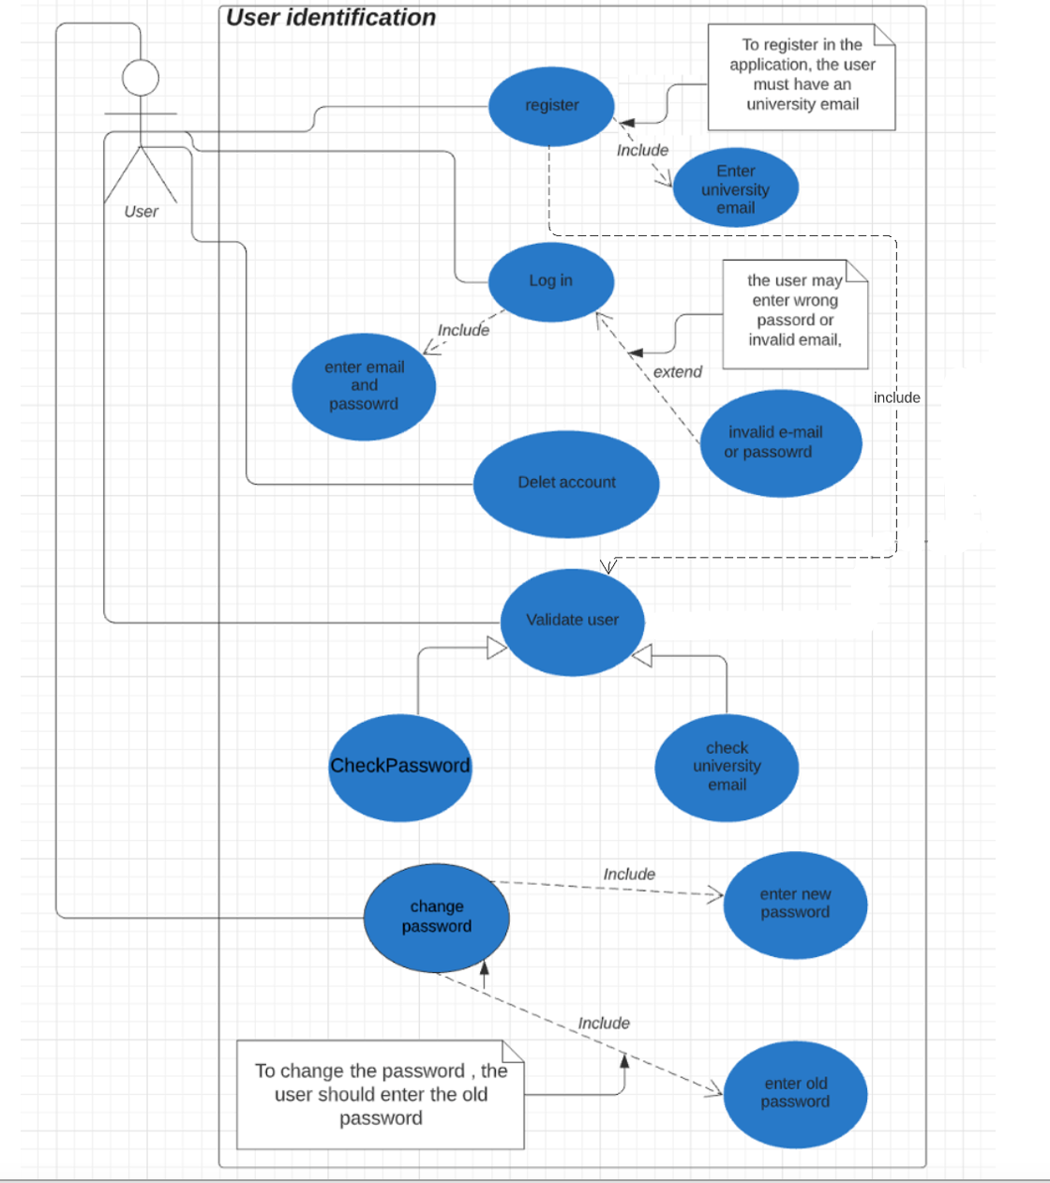

2.8.2 related to User activity:

**Done by: Musherah Moqbel**

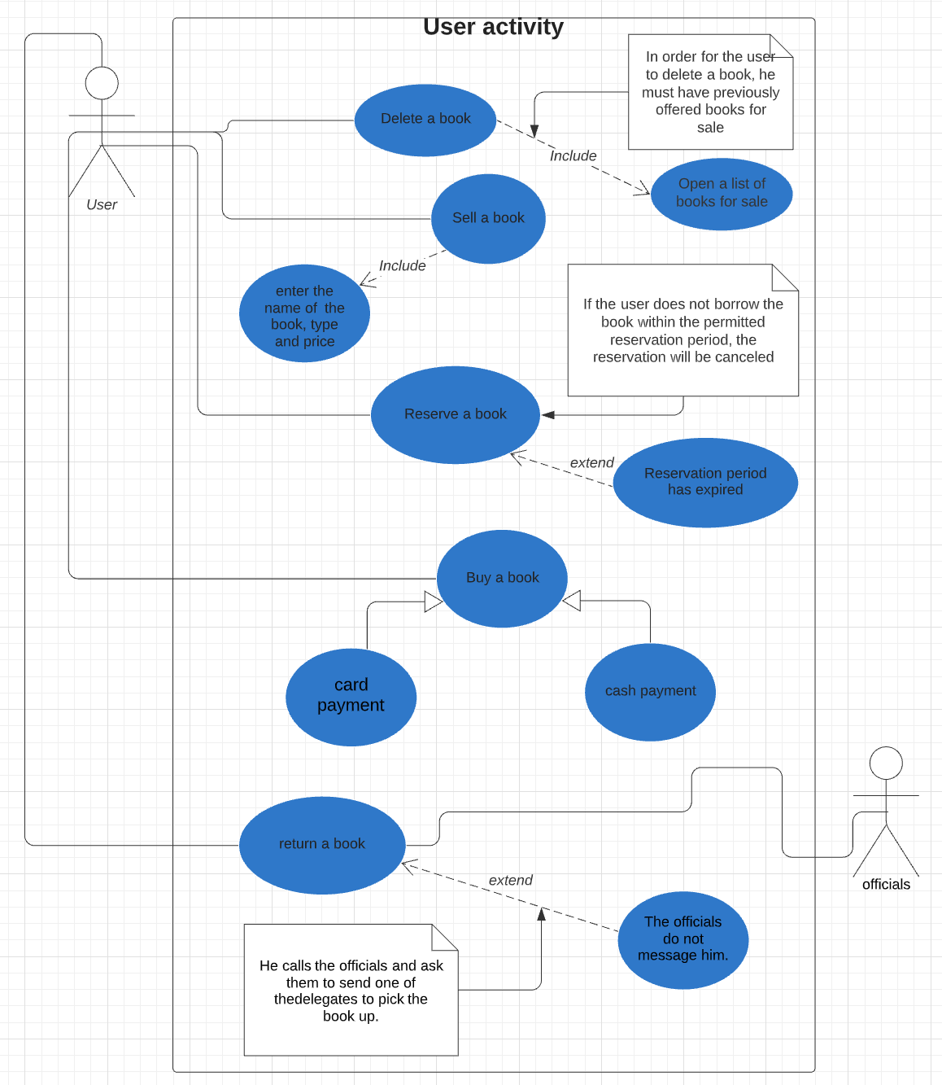

2.8.3 related to feedback activity

**Done by: Abdulla aktham**

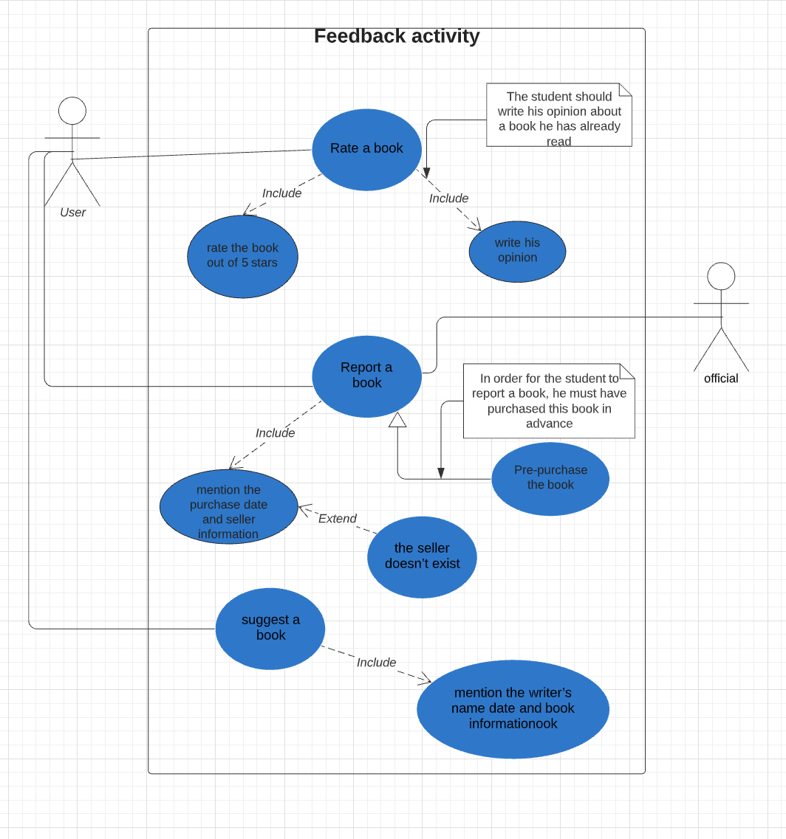

4-related to technical issue:

2.8.4 related to technical issue:

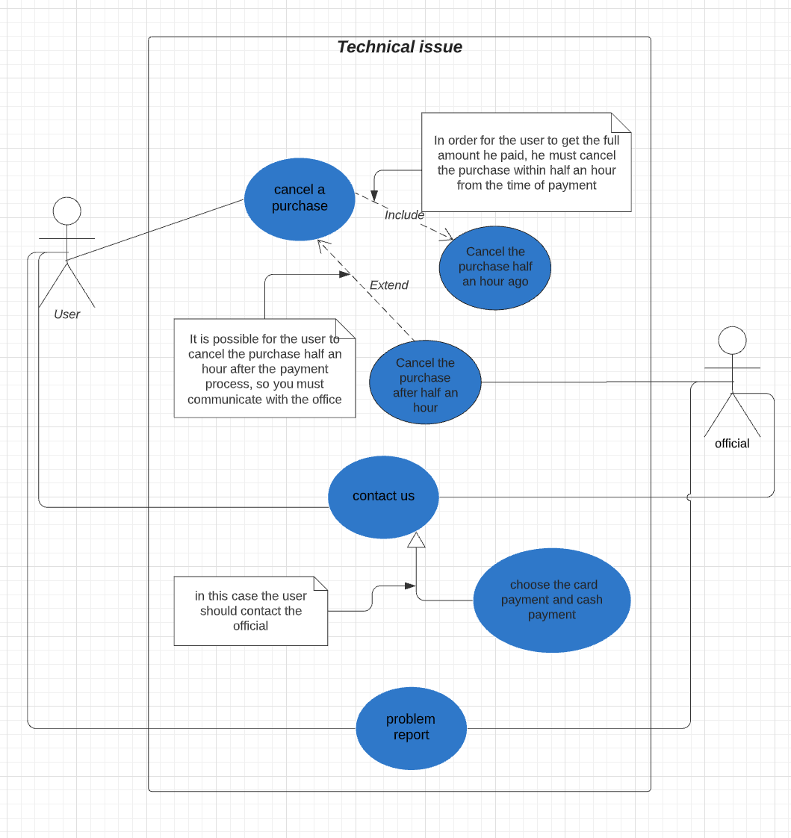**done by: Fatima Salman**

2.9 Performance Requirements:

1-Define the acceptable error rate allowed during the measurement of the response times.

2-Supplier warrants that the banking Software shall be capable of supporting at least 200 students when implemented into a suitable production environment.

3-Should run on 500 MHz, 64 MB machine.

4- 98% of the responses should be within 2 sec, except for downloading onlaine book for which more time is acceptable.

2.10 Design Constraints:

1-The system shall be developed using open-source tools and shall run on several operating system

2-The system must develop using Python.

3- The system shall be developed using the Microsoft .Net platform

2.11 External Interface Requirements:

The user screen is divided into:

1- side menu: Contains the site's categories such as the category of purchased books, books offered for sale, and paid books etc.…

2- header: contains site address, and header menu.

3- Footer: The bottom part of the screen and contains contact us and other pages available on the site

2.12 Future Extensions:

1-Compatible with future system.  
2-Renewed updates.

3- ULMS is intended to be an application can available in all operating systems and platforms.

# 3. UML Class Diagram

3.1 User Identification

**Done by: Maha Mohammed**

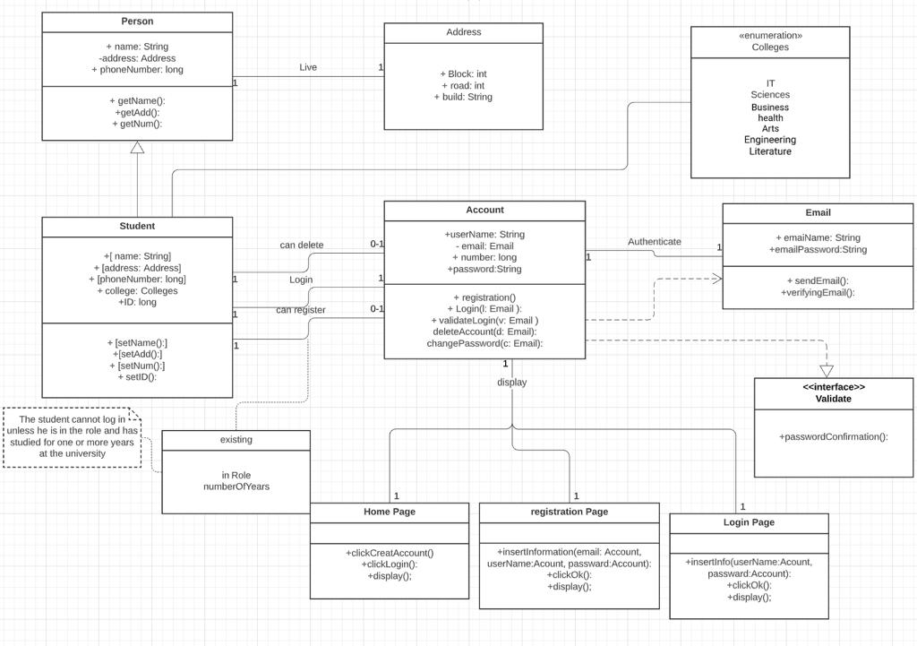

3.2 user Activity

**done by: Musherah Moqbel**

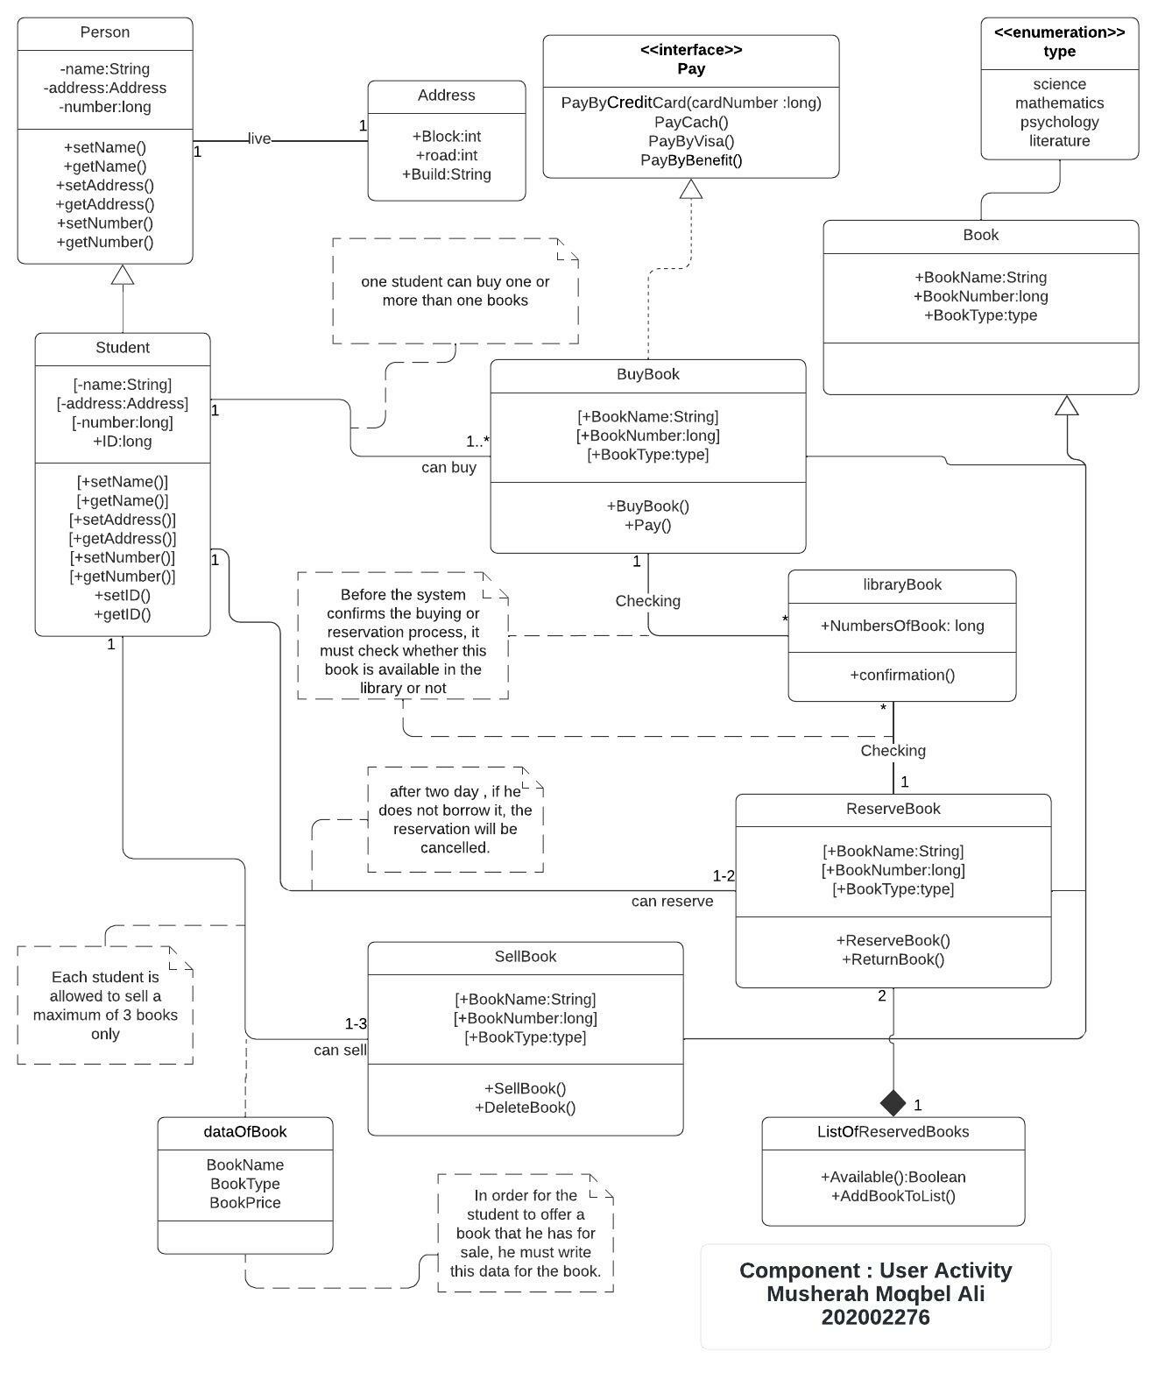

3.4 Feedback Activity

**Done by: Abdulla Aktham**

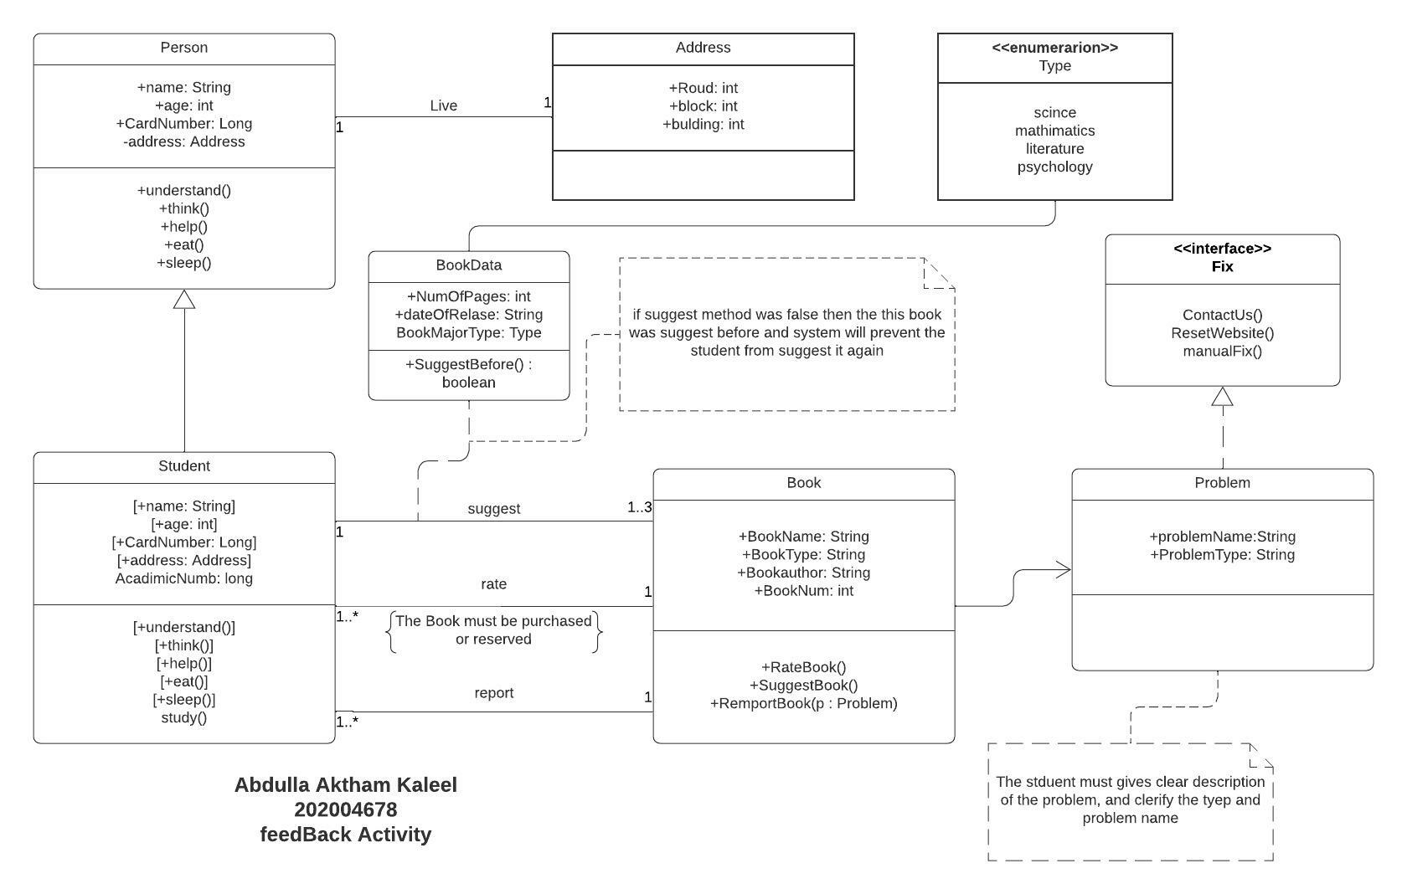

3.5 Technical issue

**Done by: Fatema Salman**

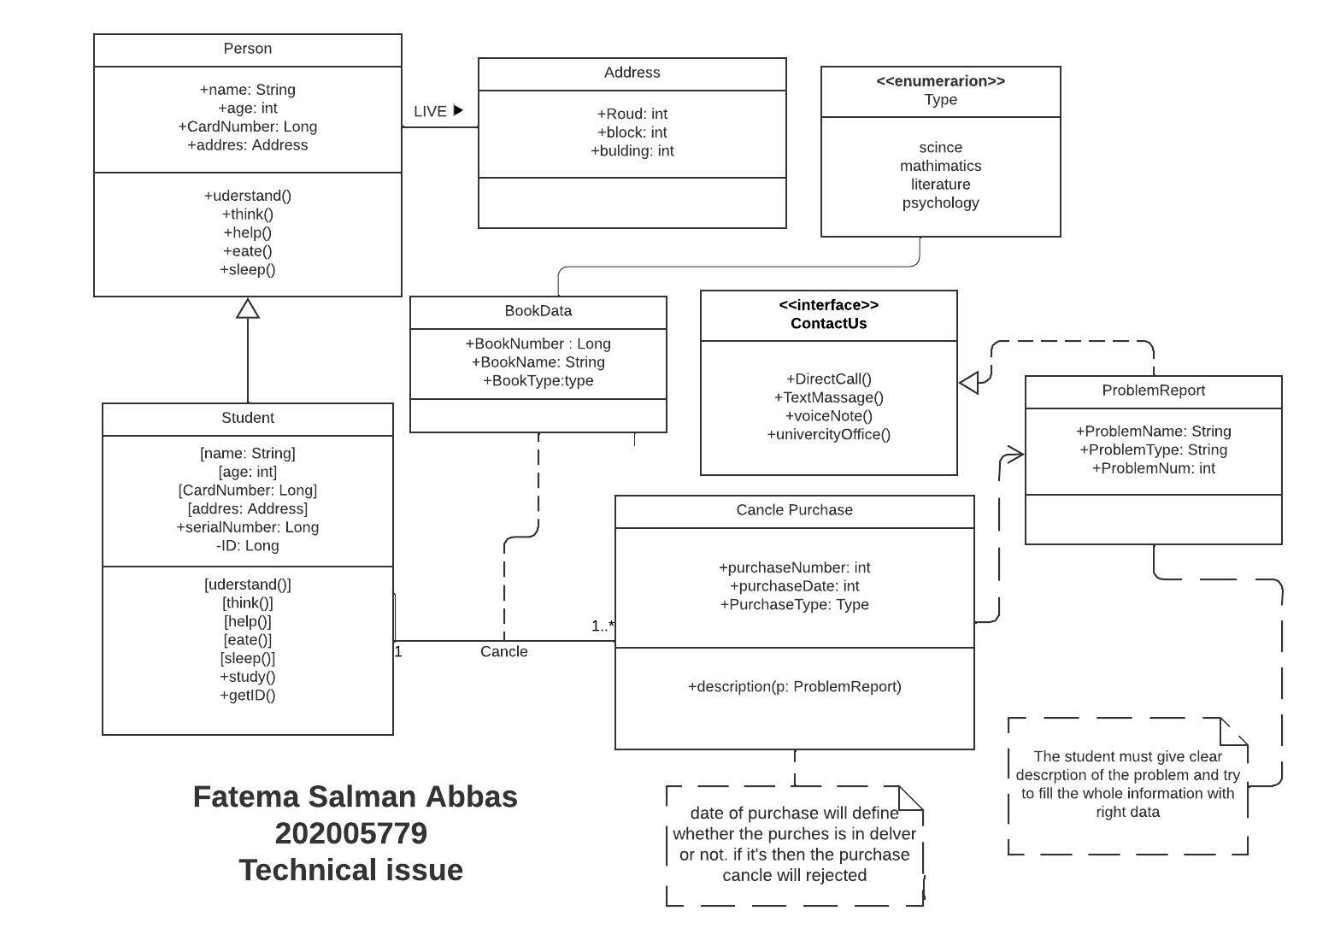

# 4. Dynamic model

4.1 Sequesnail diagram

4.1.1 Feedback Activity

**Done by: Abdulla Aktham**

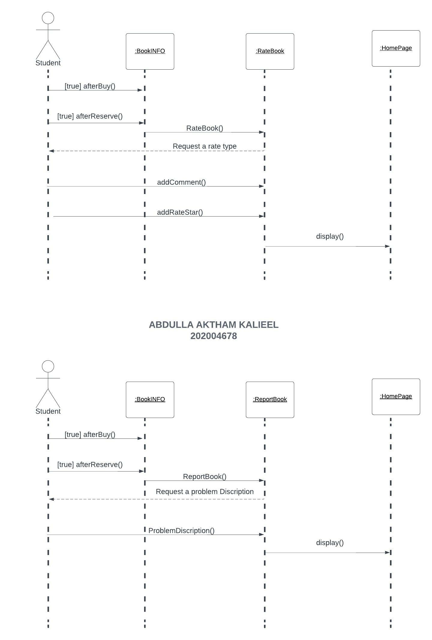

4.1.2 User Activity

**done by: Musherah Moqbel**

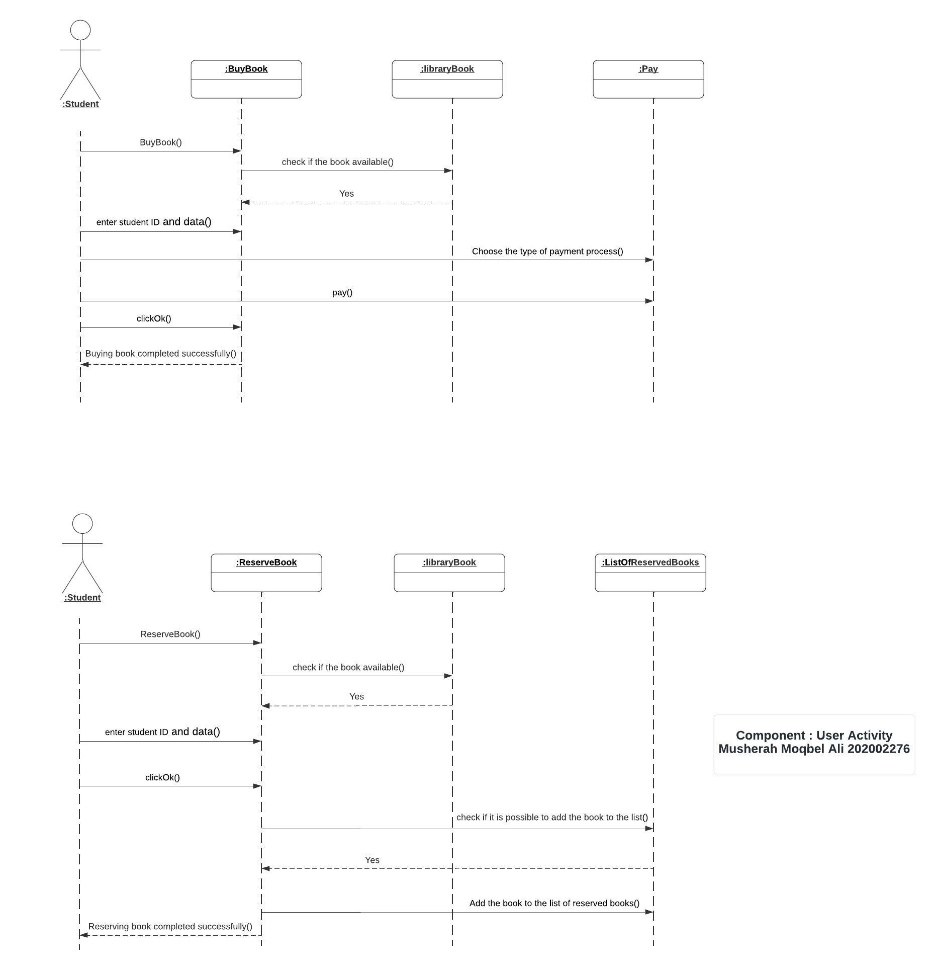

4.1.3 User Identification

**Done by: Maha Mohammed**

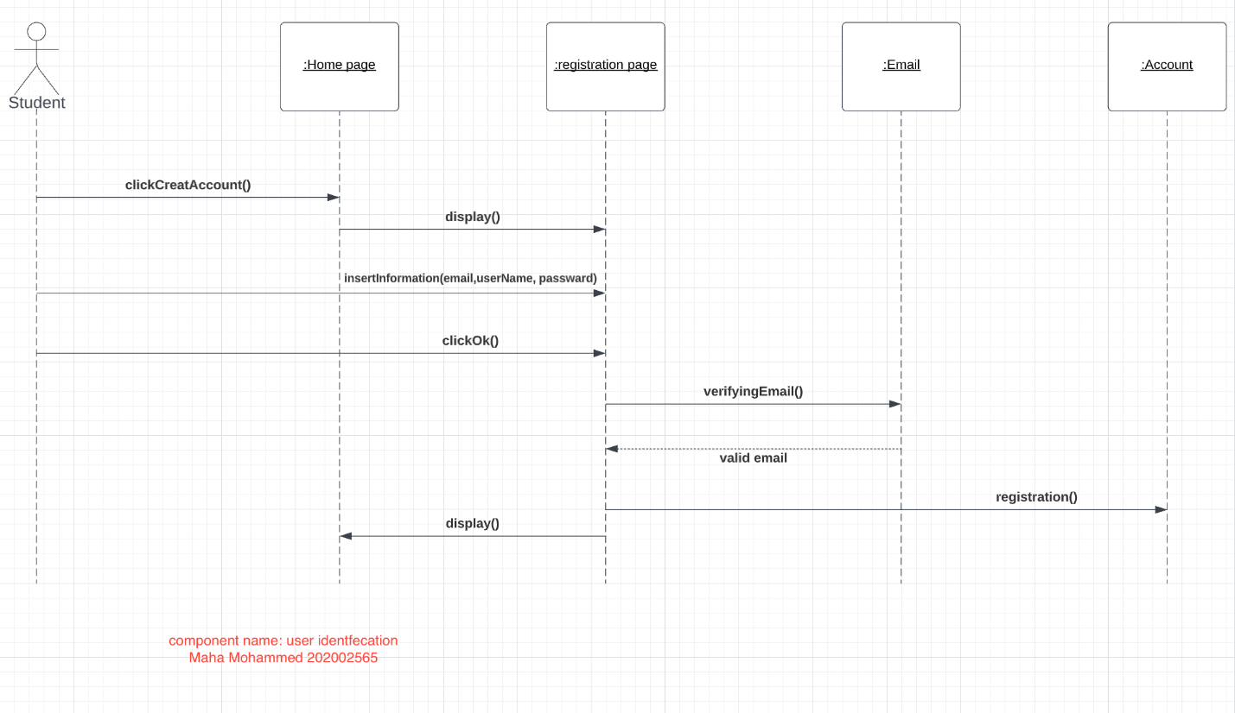

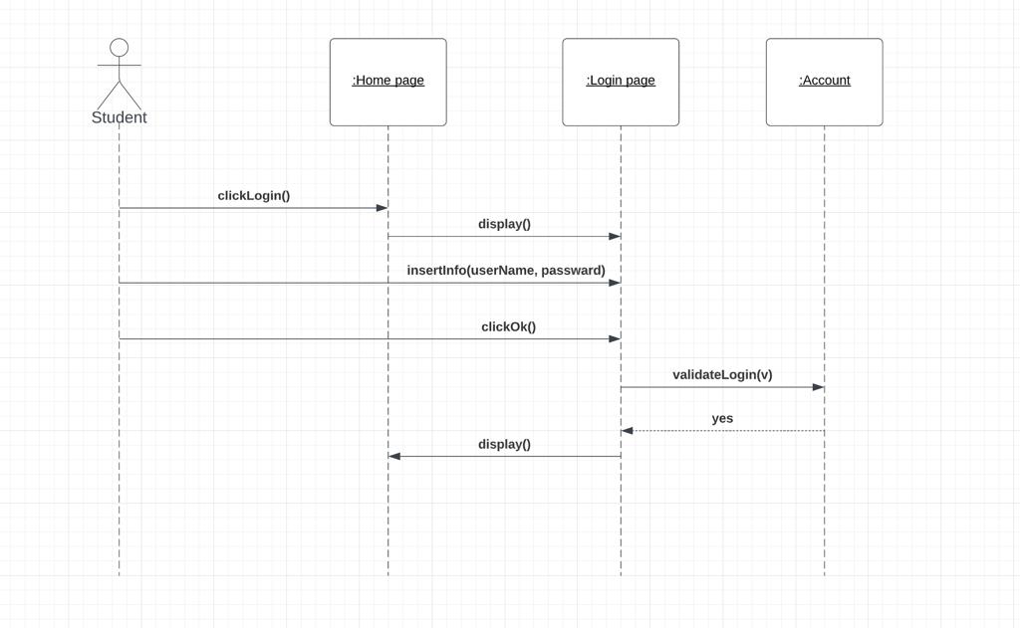

4.1.4 Technical issue

**Done by: Fatema Salman**

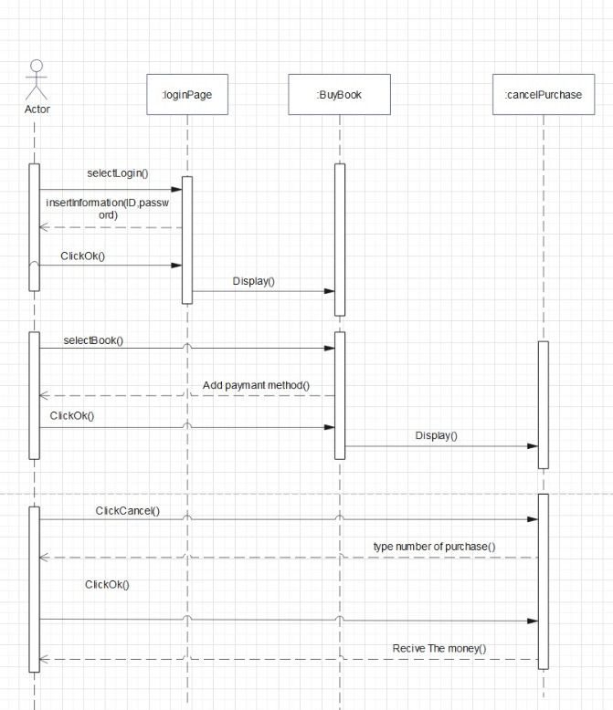

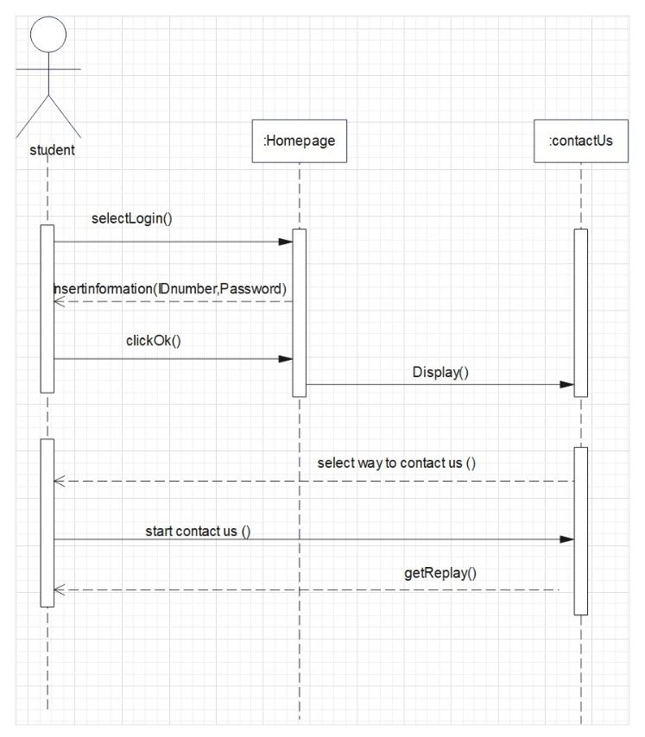

4.2 state diagram

4.2.1 Feedback Activity

**Done by: Abdulla Aktham**

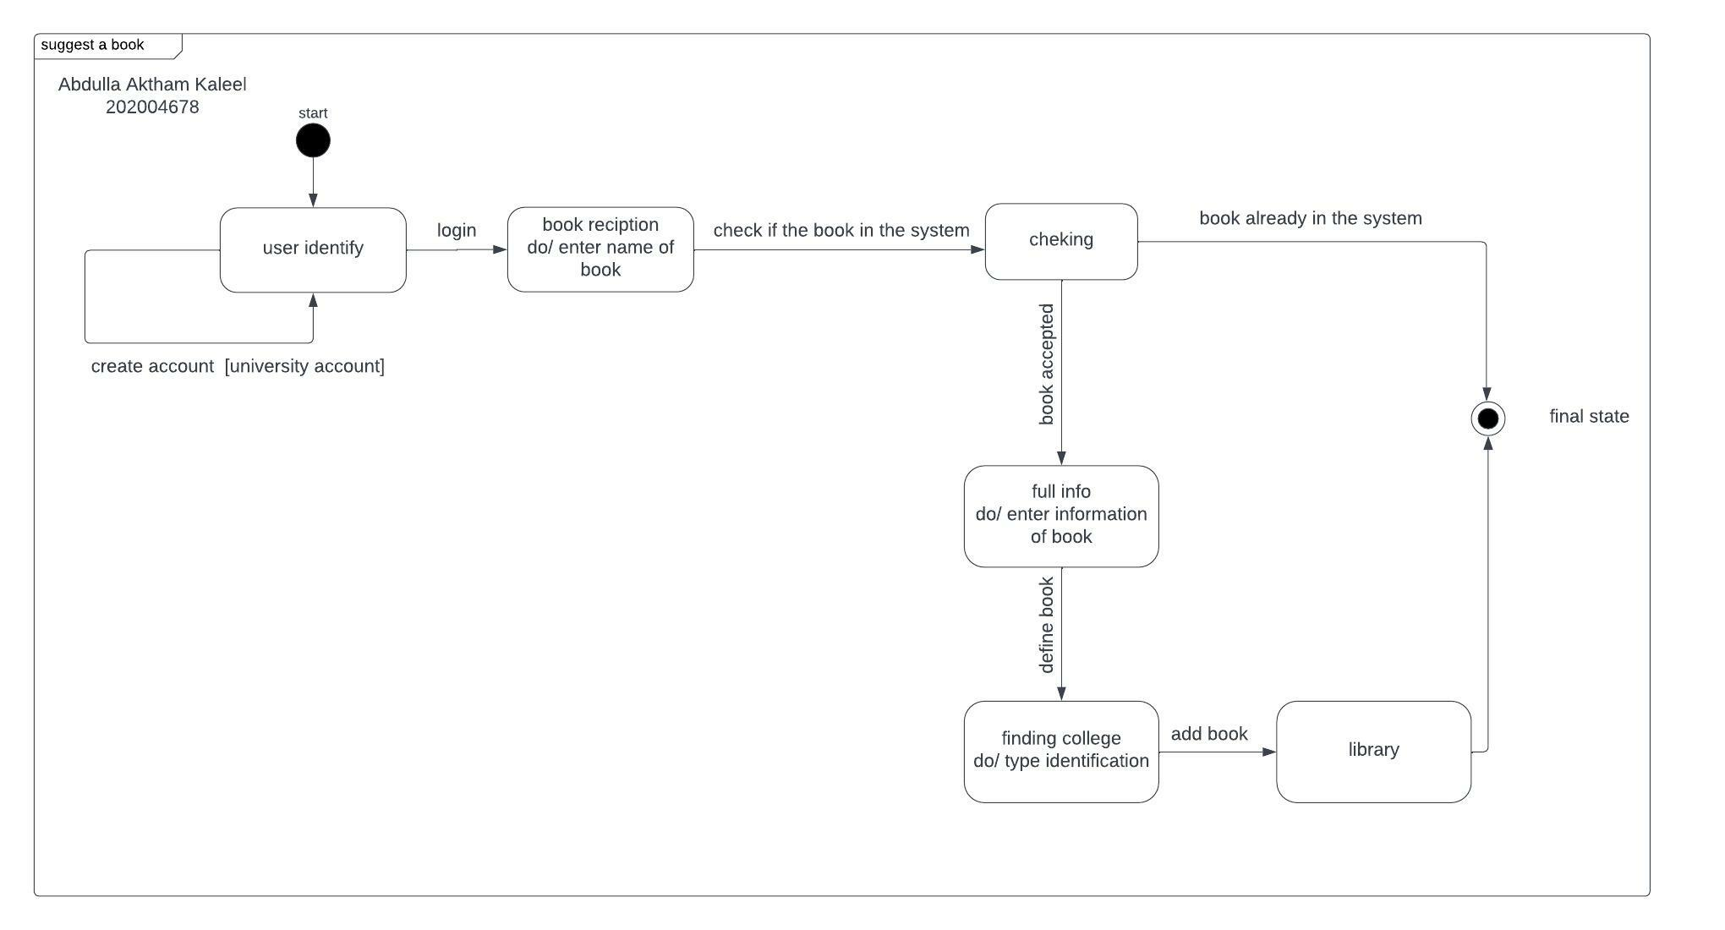

4.2.2 User Activity

**done by: Musherah Moqbel**

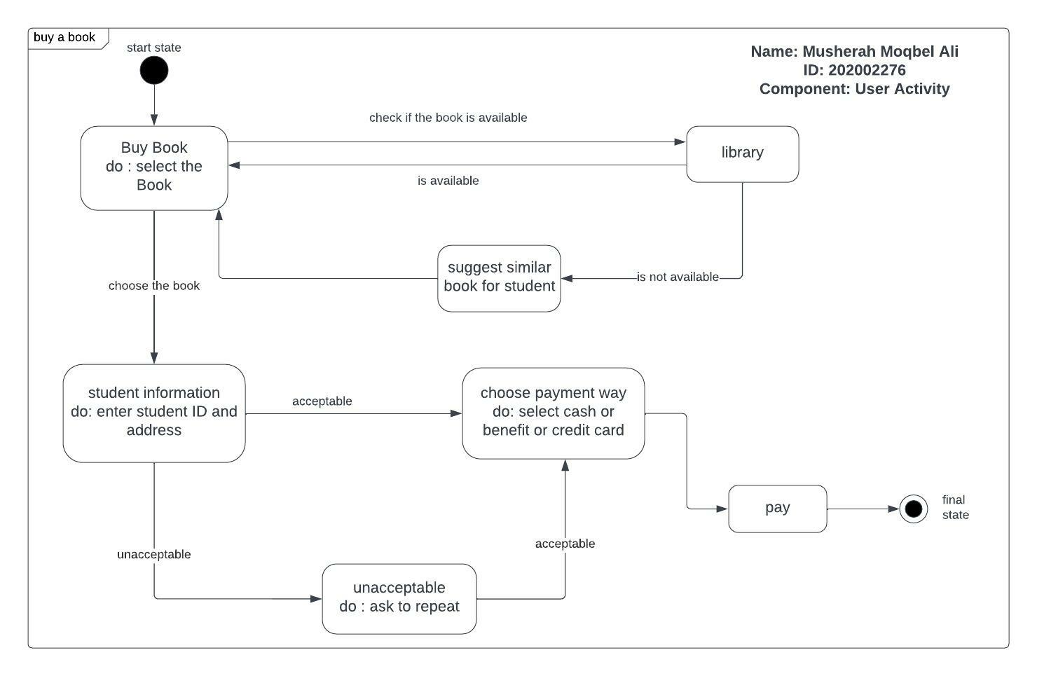

4.2.3 User Identification

**Done by: Maha Mohammed**

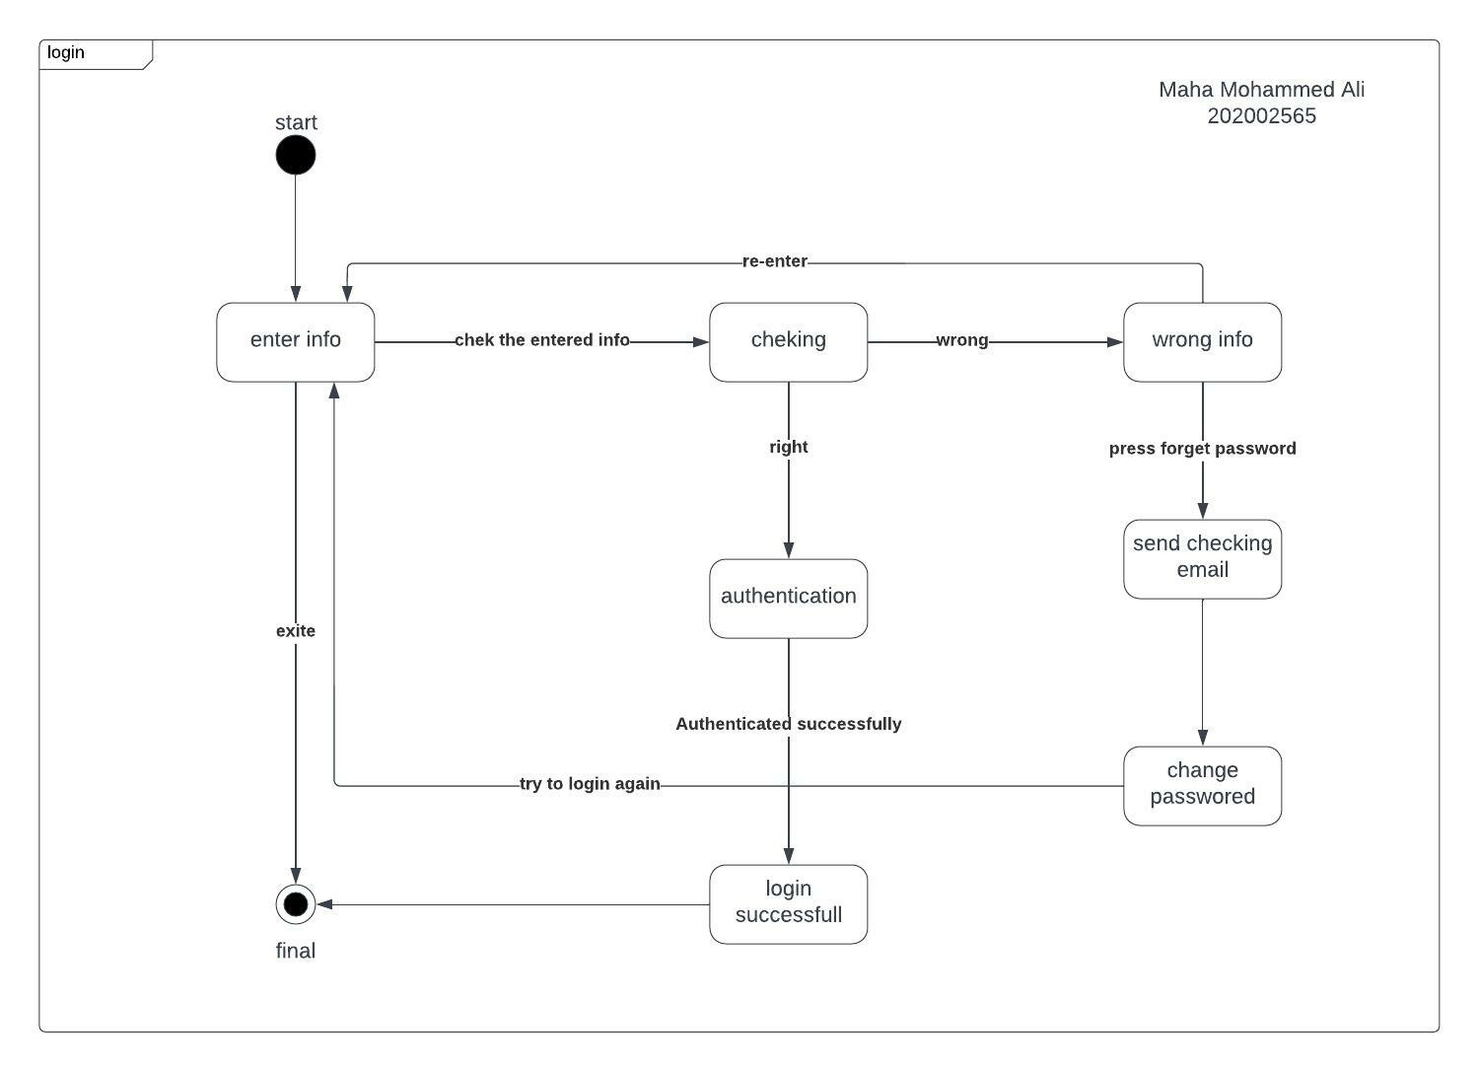

4.1.4 Technical issue

**Done by: Fatema Salman**

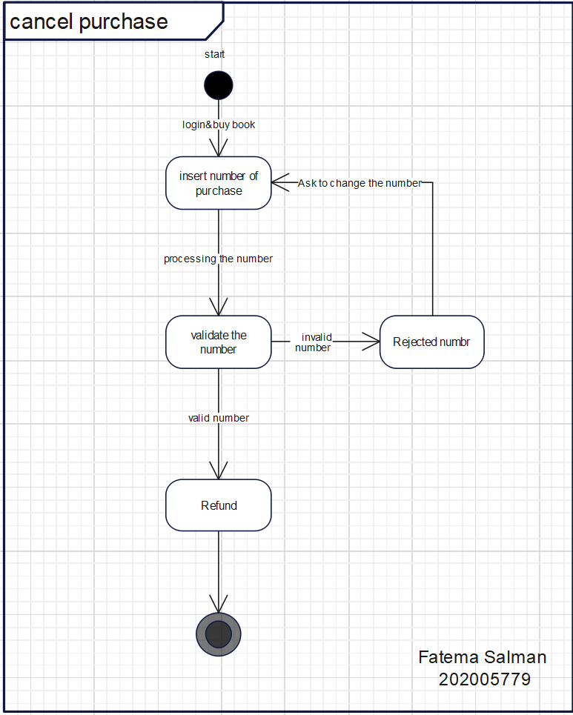

4.3 Activity Diagram

4.3.1 Feedback Activity

**Done by: Abdulla Aktham**

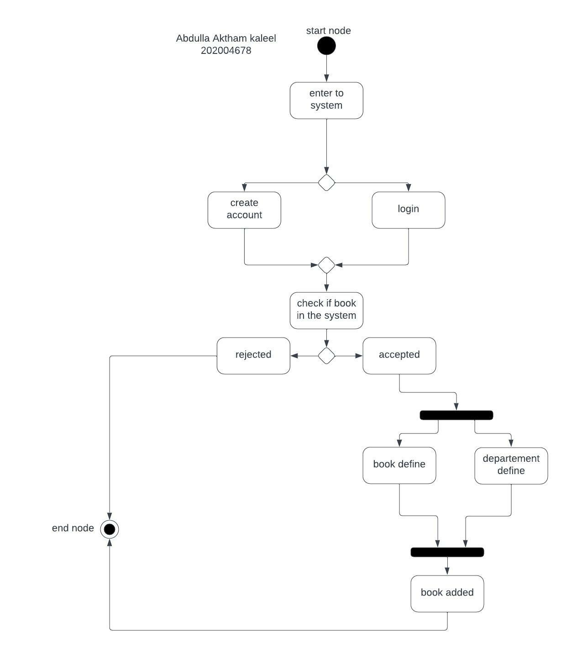

4.3.2 User Activity

**done by: Musherah Moqbel**

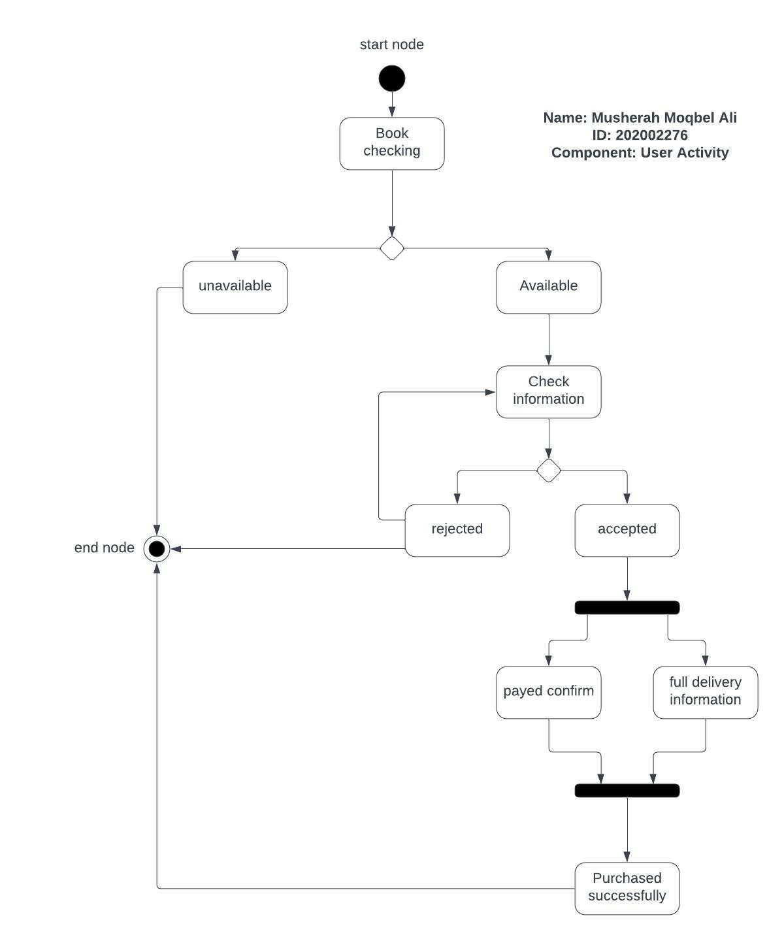

4.3.3 User Identification

**Done by: Maha Mohammed**

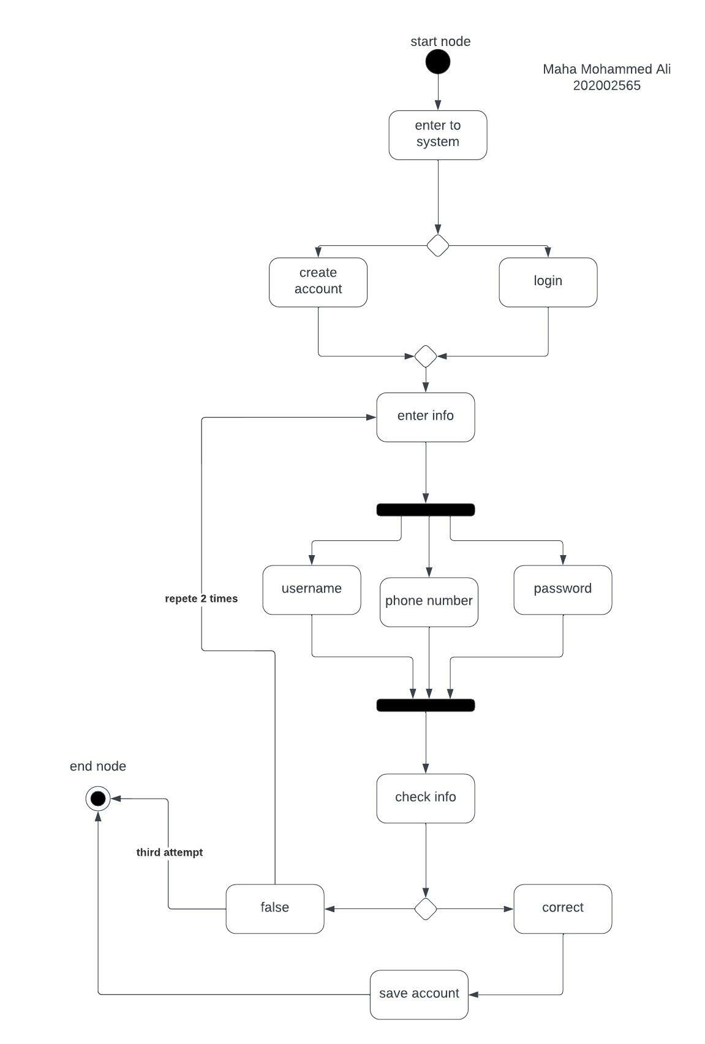

4.3.4 Technical issue

**Done by: Fatema Salman**

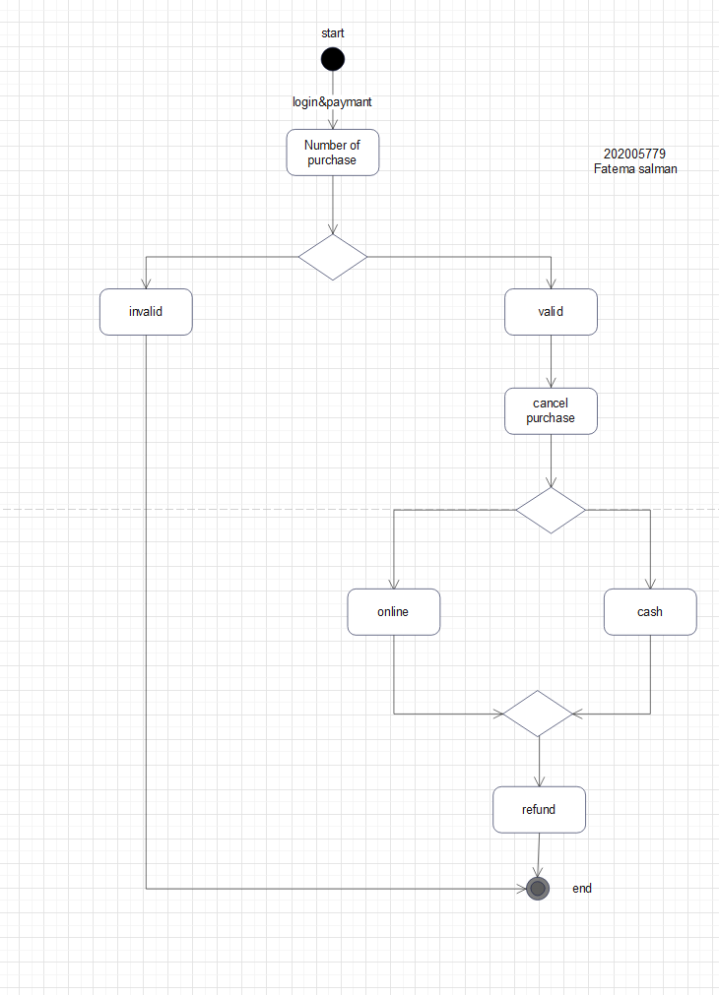

# 5. Database Relational Schema

5.1 Feedback Activity

**Done by: Abdulla Aktham**

5.2 User Activity

**done by: Musherah Moqbel**

Person table:

|  |  |  |  |  |
| --- | --- | --- | --- | --- |
| name: String[30] | Block: String[10] | road: int[4] | Build: String[4] | number: long[8] |

Student table:

|  |  |
| --- | --- |
| number: long[8] | ID: long[9] |

Book table:

|  |  |  |  |  |
| --- | --- | --- | --- | --- |
| BookName:String[25] | BookNumber:long[12] | BookType:String[20] | BookPrice:double[10] | StudentID:int[9] |

5.3 User Identification

**Done by: Maha Mohammed**

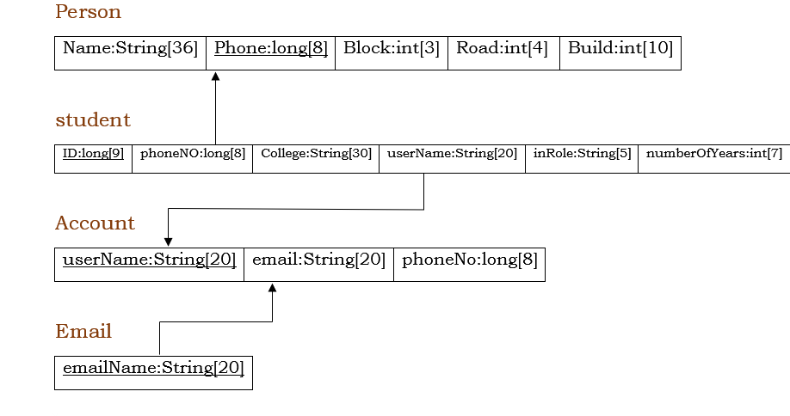

5.4 Technical issue

**Done by: Fatema Salman**

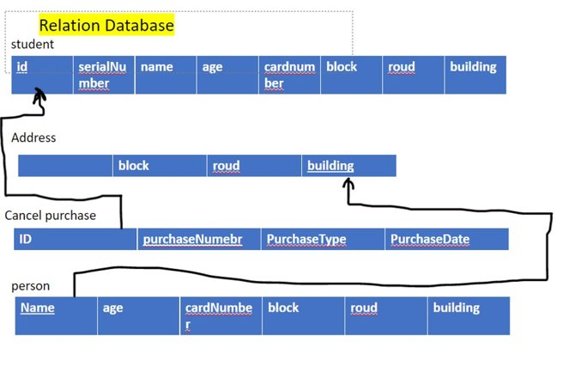

# 6. GUI Prototype

6.1 Feedback Activity

**Done by: Abdulla Aktham**

1- User will press the watch bottom to show a product.



2- Then he adds this product to his shopping card.



3- After that he buy the product from shopping card page.



4- Finally, he adds his rate and comment after payment confirmation.



6.2 User Activity

**done by: Musherah Moqbel**

















6.3 User Identification

**Done by: Maha Mohammed**

















6.4 Technical issue

**Done by: Fatema Salman**



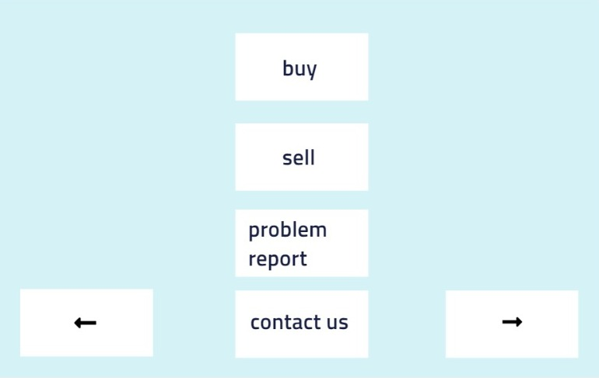

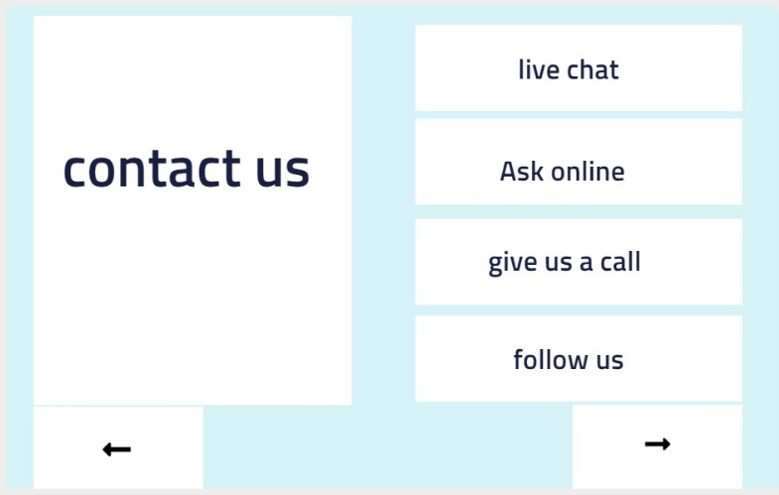

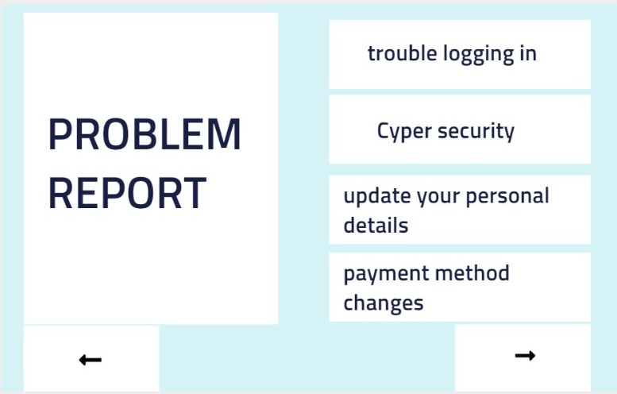

# Conclusion

F

inally, our system can work on different platforms such as mobile, websites, or even an application on a computer. Therefore, our system focuses on helping students find their exciting books related to their major and help them get dependent resources that they can use in their studying journey. In addition, our system will create a share information process by rating activities or even suggesting that make students work together toward one goal.